JavaScript Functions and Scope

1. Function to Add Two Numbers
Description:
A function is a block of code used to perform a task. This function takes two numbers and returns their sum.
Example:
function add(a, b) {
return a + b;
}
console.log(add(5, 3)); // Output: 8

2. Function Expression to Multiply Two Numbers
Description:
A function expression means storing a function inside a variable.
Example:
let multiply = function(a, b) {
return a * b;
};
console.log(multiply(4, 2)); // Output: 8

3. Arrow Function to Subtract Two Numbers
Description:
Arrow functions are a shorter way to write functions in JavaScript.
Example:
let subtract = (a, b) => {
return a - b;
};
console.log(subtract(10, 4)); // Output: 6

4. Function with Parameters and Return Value
Description:
A function can take inputs (parameters) and return a value.
Example:
function square(num) {
return num * num;
}
console.log(square(5)); // Output: 25

5. Global vs Local Scope
Description:
Global variables are accessible everywhere. Local variables are accessible only inside the function.
Example:
let globalVar = "I am global";
function testScope() {
let localVar = "I am local";
console.log(globalVar);
console.log(localVar);
}
testScope();
console.log(globalVar);
// console.log(localVar); // Error
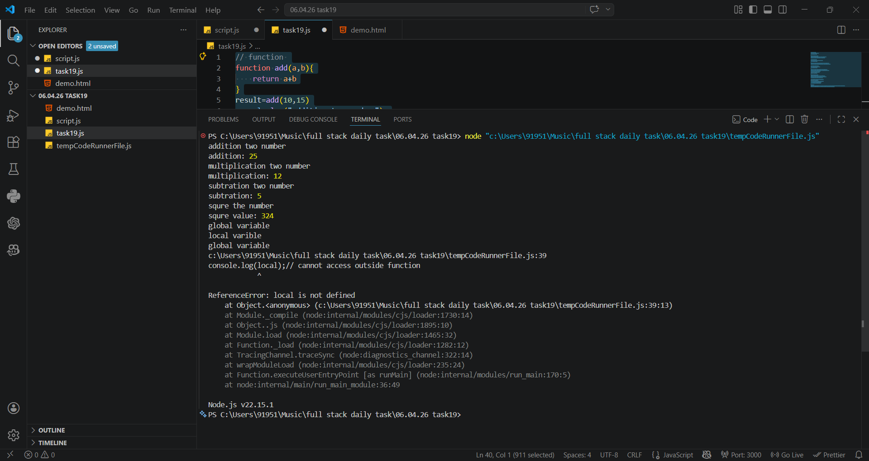
OUTPUT:

